# An Iowa Legacy Recipe

The award-winning cornbread recipe from the 1930 Iowa State Fair had been lost to history. Fairgoers raved about how good it was. It was the perfect combination of fluffy cornbread, chewy kernels of corn, and crispy bacon bits. Old timers still talk about it and recall how it was their favorite fair food. The recipe is prized by Iowans because it uses all of the major commodities grown or raised in Iowa (corn, soybeans, pork, and eggs). The cornbread is the perfect accompaniment to a delicious beef roast or beef chili stew.

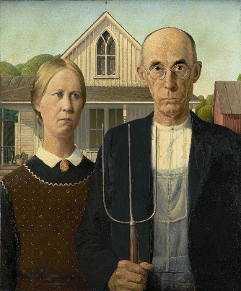

Many have tried to recreate the recipe, without success. It just never comes out quite right. It was recently learned that the recipe had been inscribed on a copy of the iconic American Gothic painting painted by Iowa native Grant Wood. The painting was hidden in a lockbox for safe keeping. No one has been able to crack the code and open the lock box.

You and your team have been asked to open the lock to rescue the painting and the recipe.

Your first clue can be found in the My Family’s Beef Farm book.

1. Iowa raises a lot of cattle. Cattle are butchered to make more than 38 different cuts of lean beef. One serving of lean beef is ­­­­___ ounces and provides 10 different nutrients your body needs each day. You get all of those nutrients for approximately ______ calories.

Lock combination: ____ ____ ____ ____

1. Iowa is the top pork producing state in the country. Iowa pork is eaten in every state. It is also shipped around the world. How many pounds does a pig weigh when it goes to market?

Agriculture is Everywhere! Just waking up in the morning you interact with a lot of different things that come from agriculture. How many?

The lock combination is the weight of the pig plus the number of items from agriculture:

____ ____ ____

1. Farmers use a lot of technology to operate their farms. Technology like Unmanned Arial Vehicles or drones help farmers scout fields for bugs, weeds, or fungi. You can learn all about drones on the marked pages of My Family’s Soybean Farm.

Lock combination: Right ____ Left _____ Right _____

1. In the My Family’s Corn Farm book we learned all about the different parts of the corn plant. Several parts of the plant are spelled with five letters. Interesting!

Lock combination: _____ ____ ____ ____ ____